Module 11 – EOQ

Exploratory Data Analysis

*In this section, you should perform some data analysis on the data provided to you. Please format your findings in a visually pleasing way and please be sure to include these cuts:*

* *Make line graphs showing the following data over time:*
  + *Sales*
  + *Unit Purchase Cost*
  + *Fixed Order Cost*

Model Formulation

*Write the formulation of the model into here prior to implementing it in your Excel model. Be explicit with the definition of the decision variables, objective function, and constraints. Please restate the variables in the algorithm (i.e. D = Annual Demand)*

MIN:DC+(D/Q)S+(Q/2)c = 17343\*53.55+(17434/Q)\*193.46+(Q/2)\*10.1745

Q=sqrt(2DS/C) = sqrt((2\*17434\*193.46)/10.1745))

Constraints: Q>0

Model Optimized for Minimizing Costs with Optimal Order Quantity

*Implement your formulation into Excel and be sure to make it neat.*

*The company should order 814 items every time they need more inventory. The number of items purchased is the minimized cost between stockouts and surplus inventory. The company needs to purchase 17434 items each year where it costs $53.55 per unit and $193.46 to place an order. The total cost of buying all items for the year is $941,876.63.*

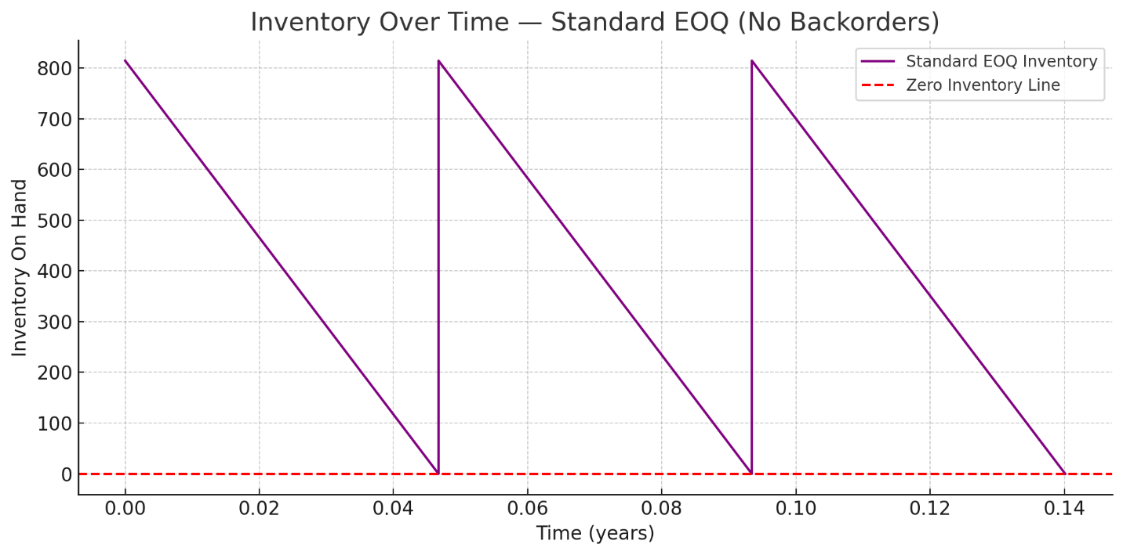

Model with Stipulation

*Please copy the tab of your original model before continuing with the next part to avoid messing up your original solution.*

*Implement the below EOQ extension, EOQ with planned backorders. We have added 2 new variables: A = shortage cost & b = planned back orders. Restate the previous variables with these new ones please. Note, you’ll need to solve for both Q\* and b\* here to get the optimal solution. You should start Q out as the EOQ from the previous section and b as 0. Also, note that this algorithm does not include `D \* C` as it’s not relevant to this analysis*

**

*Lastly, do the following:*

* *Explain why you may include planned backorders (i.e. plan to accept purchases when out-of-stock such that some customers will wait for their purchase). Please think critically prior to doing any searches for why*

*Planned backorders are a strategic decision companies make to intentionally allow stockout for short periods. This can be beneficial due to lower holding costs, capacity constraints, and demand uncertainty buffer. Backorders offer flexibility in environments where demand fluctuates or is difficult to predict. Rather than overstocking to meet every peak, firms can meet demand later.*

* *Make a similar “sawtooth chart” with the results here. Note, it will be very similar as before, but inventory will go below 0 before replenishing*